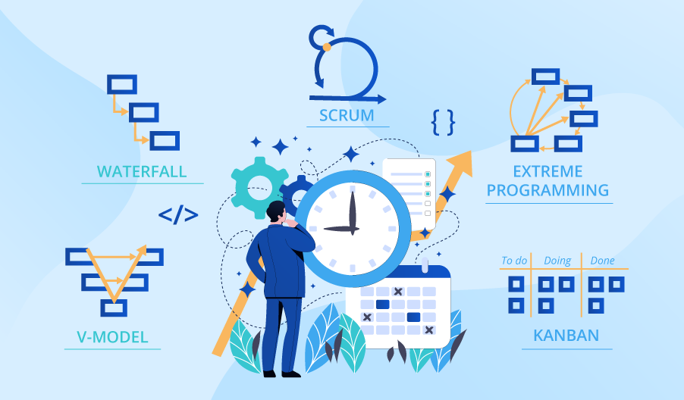

**SE423**

**Software Project Management**

**Assignment**

**Assignment 3.**

Answer the following questions:

1. Define software quality and discuss its importance in software development.
2. Explain the concept of software quality assurance and its role in ensuring high-quality software.
3. Identify and evaluate common activities associated with software quality assurance. Which activities do you believe are most effective in ensuring software quality?
4. Compare and contrast different techniques available for conducting technical reviews in software development. What are the advantages and disadvantages of using each technique?
5. Your project plan requires all software artifacts to undergo formal inspection, but you are falling behind schedule. Analyze your options for the inspection process and provide a recommendation for how to proceed.

Submit your answers to LMS as PDF file.